- 1. Not letting login with old user
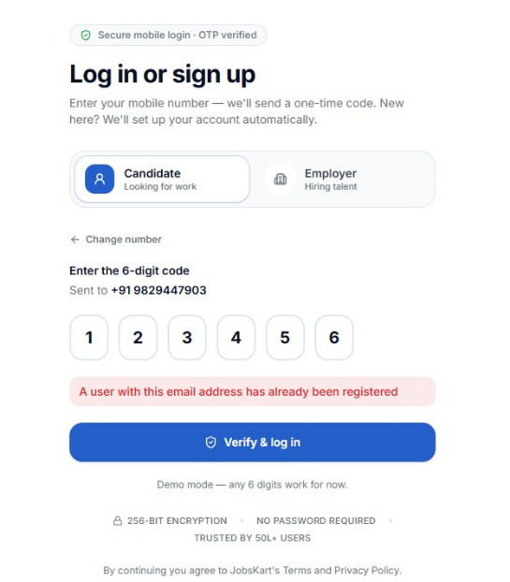

- 2. Some PDF Resume Still not parsing, attached 2 sample resumes in chat for ref, try both.
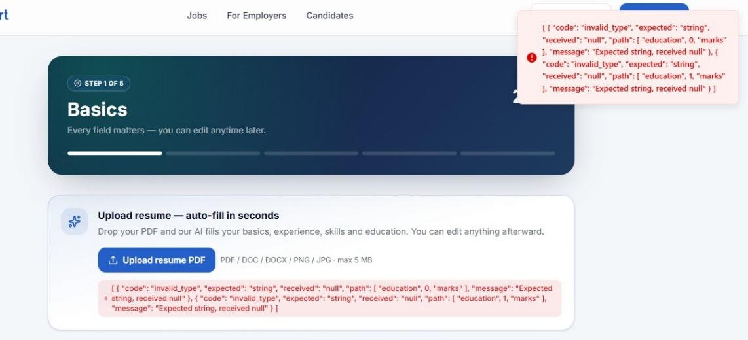

- 3. The image was uploaded successfully, but the parsing process did not start and same issue with the docx file.
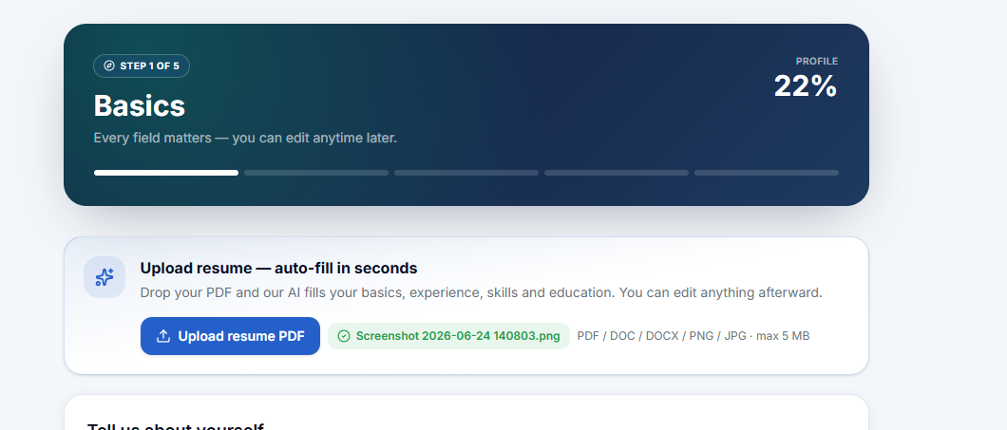
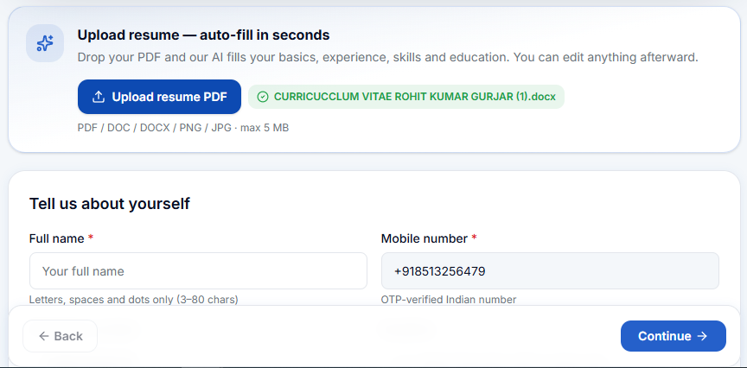

- 4. Work status - Switching from fresher to Exp or vice versa etc., it goes back to step one. Attaching video for ref.
- 5. Fresher - Ai skills showing but selection not showing on this screen.
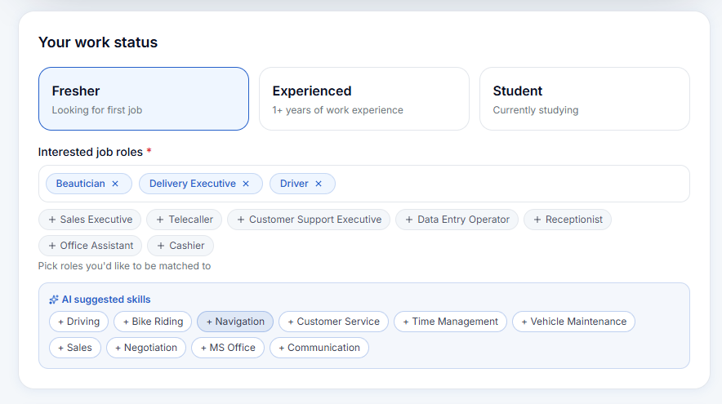

But was saved and here showing. Suggestion - Skill selection AI based should be only one time, either on this screen or the earlier one.
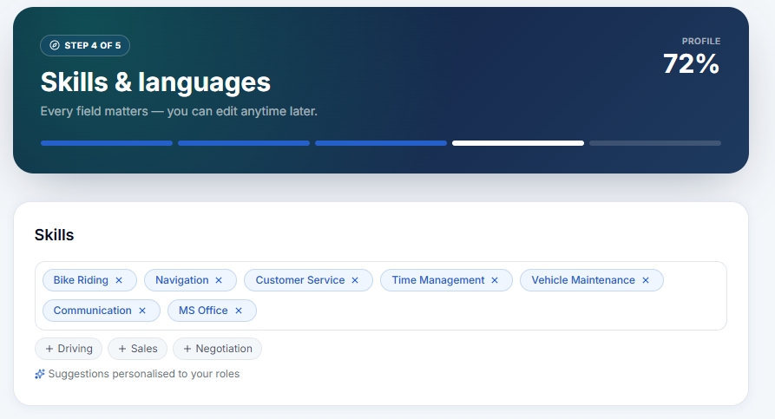
Lets Say Beautician is selected as preferred job role, is really AI suggested skills will come here or from our DB skills will be fetched here?
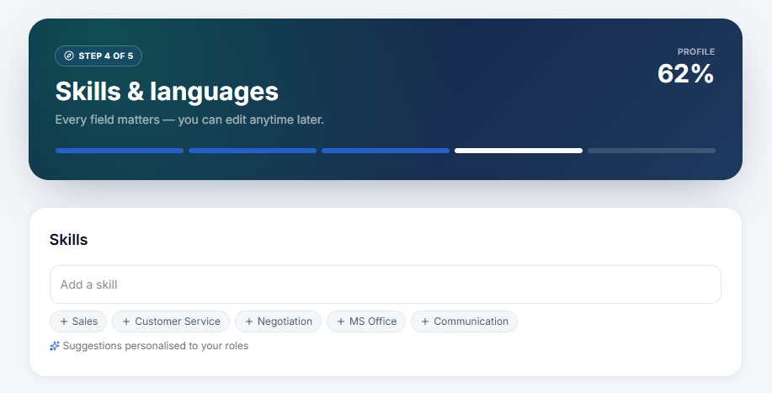

- 6. Multiple Selection Needed here.
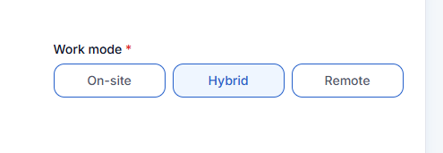
- 7. Remove this duplicate upload resume option on the last screen.
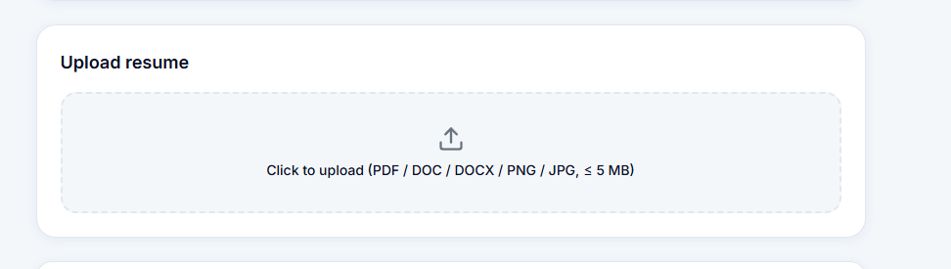
- 8. Revised Word Limit - 200 Characters
